Recipes

You need to add 17 things to this document. (Make sure to number them just as I did in the example.) It may be helpful to copy and paste this list and then fill it in as you go along. All image names must start with your location, e.g yellowstone_sunset.jpg unless you are using a link from the internet.

1. Name of recipe: Pesto Pasta
2. **Origin**: Italian
3. **Source**: https://www.simplyrecipes.com/recipes/fresh_basil_pesto/
4. **Category**: Main Dish
5. 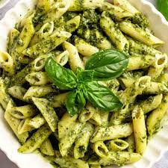
6. pesto_pasta.jpg
7. Pesto pasta has always been a comfort dish for me; it’s quick, it’s easy, and great food for a dinner party or a comfy night in! It requires six main ingredients, plus additional spices as you see fit. If you’re not in the mood for pasta, you can always eat the pesto sauce on bread, crackers, or eggs! This recipe makes enough for around 4 people, so adjust accordingly.
8. **Recipe Ingredients – Just write Recipe Ingredients**
   1. 2 cups fresh basil leaves, packed (can add some spinach if you don't have enough basil leaves)
   2. ¾ cup freshly grated Parmesan or Romano cheese
   3. ½ cup extra virgin olive oil
   4. ⅓ cup pine nuts (can sub with same amount of chopped walnuts)
   5. 3 cloves garlic, minced
   6. Salt & pepper to taste
   7. 8 oz of your choice of pasta (my preferred is penne, but any type will work)
9. **Recipe Steps – Just write Recipe Steps**
   1. Heat up water in a pot for the pasta and put in a teaspoon of salt.
   2. Pulse the basil and pine nuts in a food processor. Add a bit of olive oil as need be if the ingredients are too dry.
   3. Add the garlic and cheese to the food processor.
   4. Once water starts boiling in the pot, add pasta. Stir every couple of minutes.
   5. While the food processor is running, slowly pour in olive oil.
   6. Once pasta is al-dente, turn off the heat and drain the pasta water. Save some of it if you want your pesto to be slightly thinner.
   7. Add the pasta back into the pot, mix in the pesto, and voila!
10. **Additional Food images**

For the next three pictures you can just put the names of the files, you don't have to include the files in this drive, but you do need to add them to the proper Google Drive.

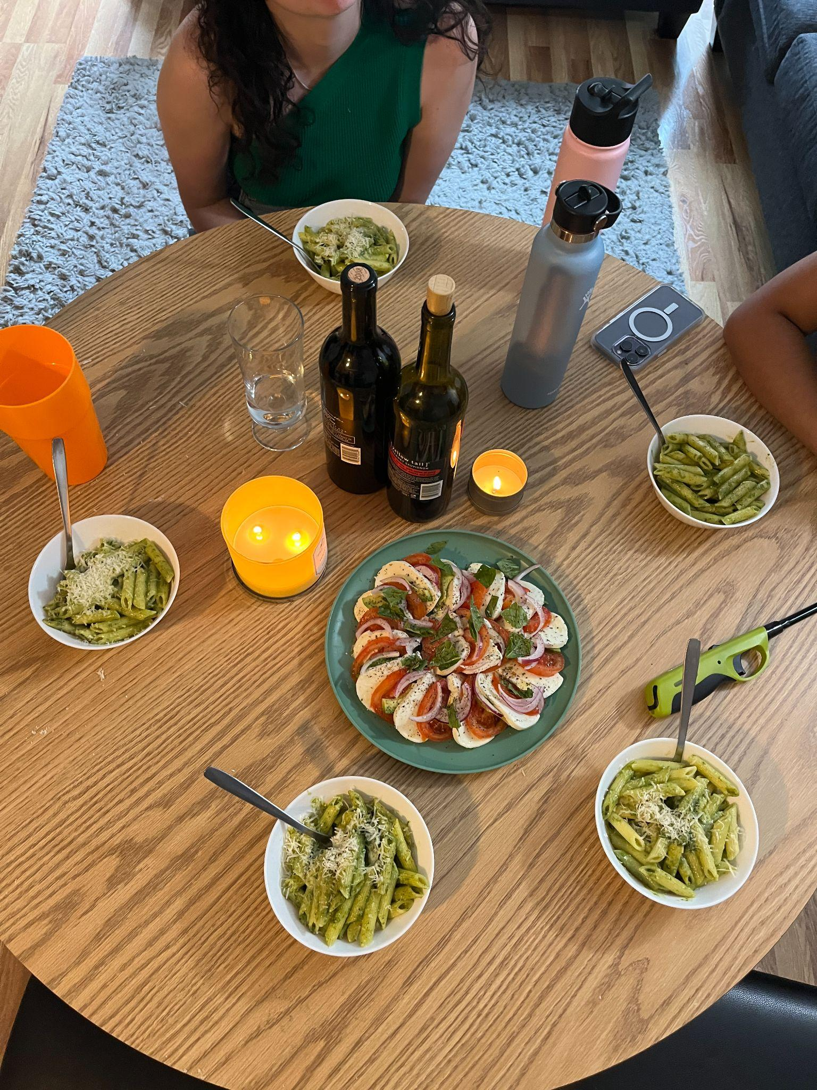

1. dinner_spread.jpg
2. Four white bowls filled with pesto pasta are on a circular round table, with caprese salad, two wine bottles, and two candles in the middle.
3. 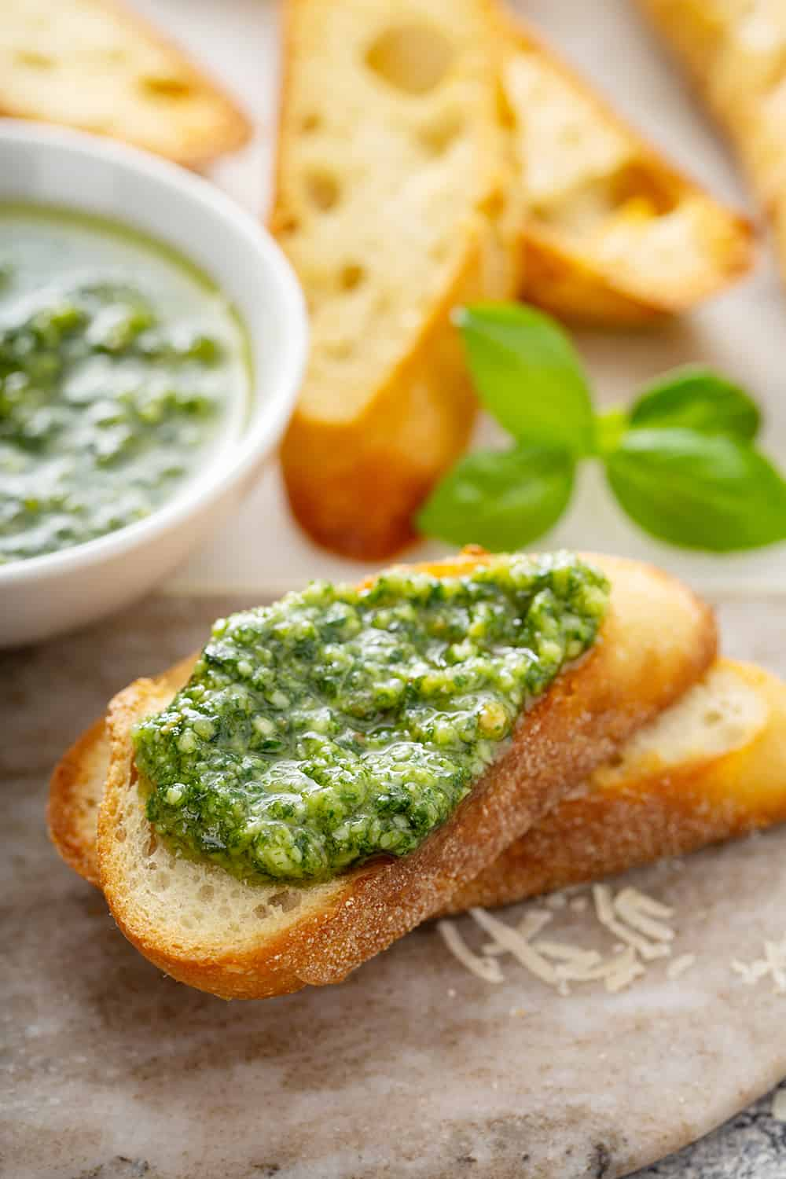
4. pesto-on-a-baguette.jpg
5. Pesto spread on a small slice of white bread.
6. 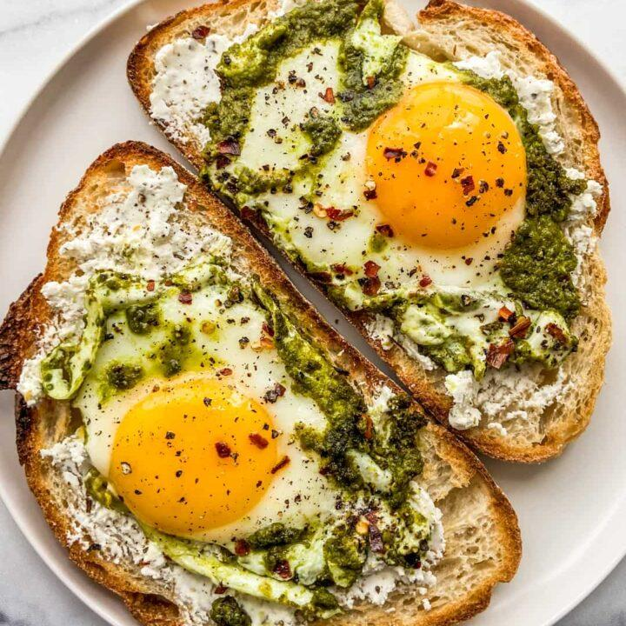
7. pesto-eggs.jpg
8. Sunny-side-up eggs cooked in pesto on 2 slices of bread on a white plate.
9. Elena Elkin